Want to study online?
- Go to http://freezingblue.com
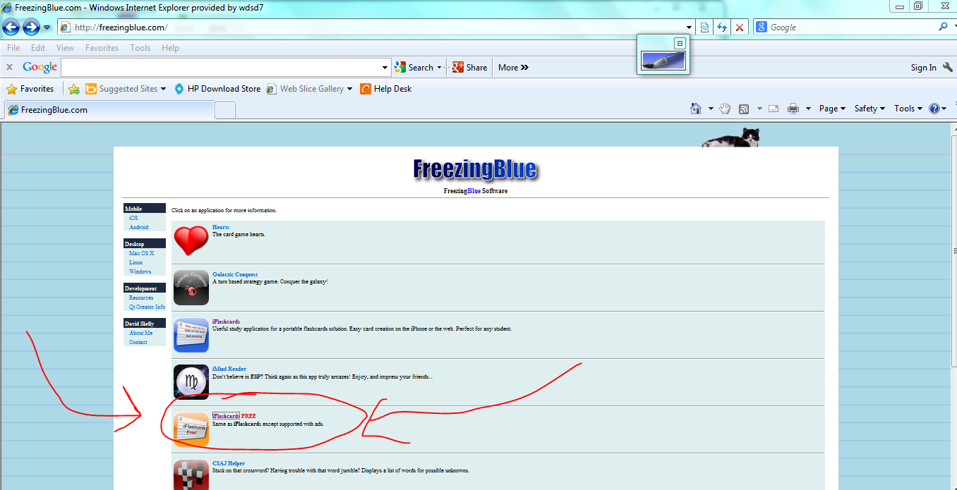
- Choose “iFlashcards Free”

- Search tags by “Author” and search for “lhasse”
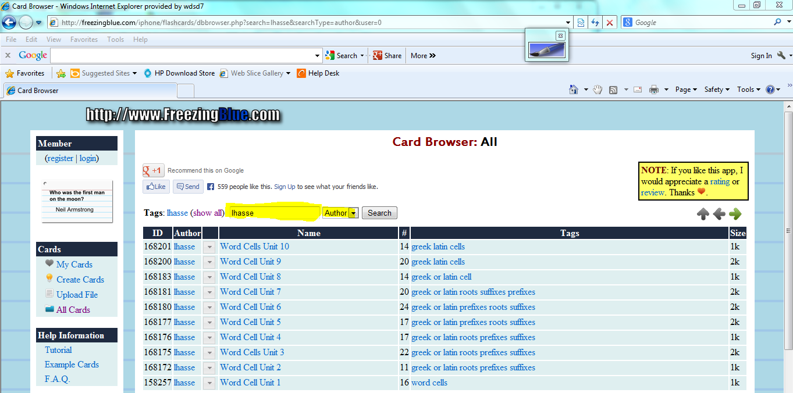
- Choose the one to download.
- STUDY!!!!!!!!!!!!!

